
2020 – Term 2
Year 8 Mathematics - End of Term Test

Resources: One A4 page of notes and a calculator

Name: _______________________________ / 51 marks Time: 50 minutes

Attempt all the questions.

Multiple Choice – Circle the correct answer 10 marks

- In a science experiment Albert needs to add 60 millilitres of acid to every 2 litres of water. If Albert only has 0.5 litres of water left, how many millilitres of acid should he add?

A 0.15 ml B 0.6ml C 15ml D 30ml

- The weatherman described the chance of thunderstorms on a given day as highly unlikey. Which probablility best describes the chance of a thunderstorm?

A $\frac{1}{11}$ B $\frac{1}{2}$ C $\frac{10}{11}$ D 1

- The colour orange can be made by mixing 5 litres of yellow paint with 8 litres of red paint. If 140 litres of yellow paint are used in this mixture, how much red paint is needed?

A 18L B 28L C 88L D 224L

- Which of the following is equivalent to $4(3m-1)$?
A $7m-1$ B $12m-1$ C $12m-4$ D $8m$

- Lachlan drives his boat to an island 100km away at an average speed of 80km/h. How long does this trip take?

A 48 minutes B 1 hour and 15 mins C 1 hour and 20 mins D 1 hour and 30 mins

- A childs bike has a circumference of 90cm. Which of these is the closest to the radius?
A 5.4cm B 14.3cm C 28.6cm D 141.4cm

- A wheel on a bicycle has a diameter of 530mm. The wheel turns 12 times. Approximately how many metres has the bicycle travelled?

A 6m B 20m C 40m D 399m

- Which expression is equivalent to $–(y-6)$?

A $y-6$ B $-y-6$ C $y+6$ D $-y+6$


- Harry sold one schnitzel wrap every 4 minutes at a surfing competition.
At this rate how many minutes would it take to sell $320 worth of schnitzel wraps?

A 25 mins B 50 mins C 80 mins D 200 mins

- Albert has 50 red marbles in a bag. He records the colour of each marble in the table below.
What percentage of the marbles are white?
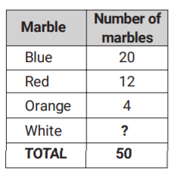

Short Answer – Show working in sufficient detail to support your answers. (43 marks)
Question 1 (8 marks)
Find the circumference and the area of the following circles
Circle | Circumference | Area
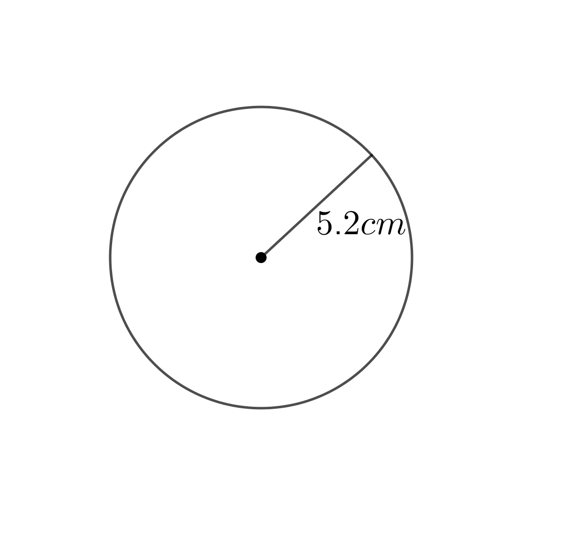
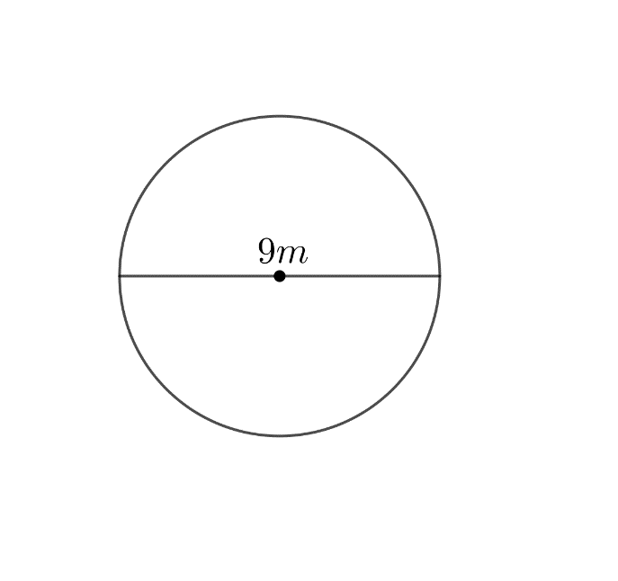

Question 2 (8 marks)
Find the area and perimeter of the semi-circle to 2 decimal places.
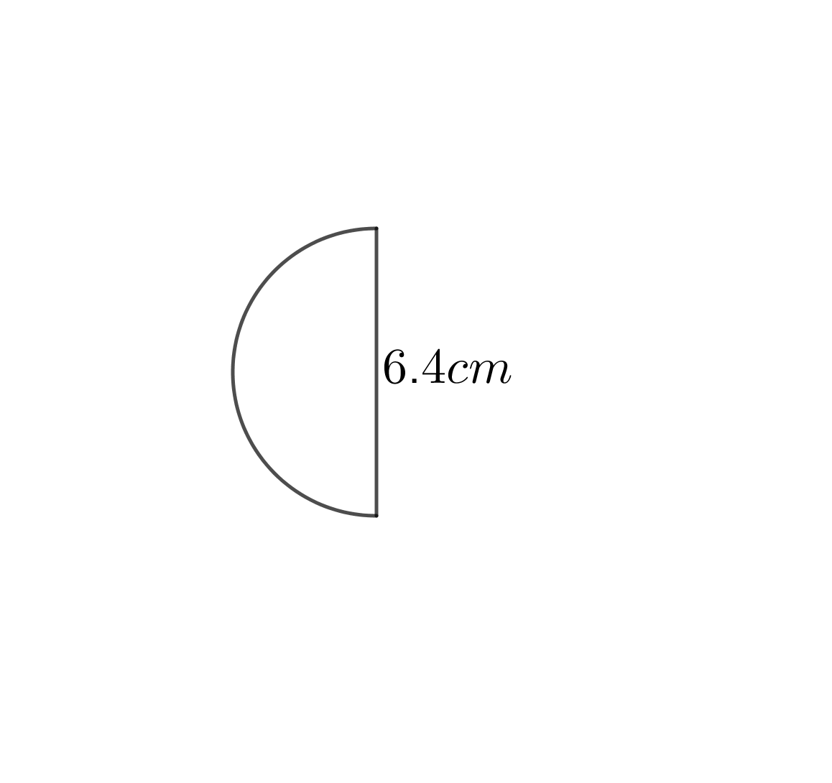

Question 3 (3 marks)
A yoyo at the end of a string moves through a quarter circle, as shown below. Find the exact value of curved distance travelled by the yoyo.

Question 4 (5 marks)
Expand and simplify where possible the following:
a) 3(m – 5) + 2m (2 marks)

b) 4(2d – 1) – 3(4e – 3d) (3 marks)

Question 5 (3 marks)
Factorise the following algebraic expressions:
- 2b +8 (1 mark)

- 9t – 15 (1mark)

- -3t – 18 (1 mark)

Question 6 (4 marks)
a) A prepaid mobile phone deal offers 29c per text message, what would be the charge for 83 text messages? (1 mark)

b) The same deal offers 43c per 30 seconds for phone calls, what would be the charge for a 3 min call to the nearest 10 cents? (3 marks)

Question 7 (4 marks)

a) Simplify the following ratios: (2 marks)
i) 4 : 8 ii) 0.2 : 1.2

b) The concrete is to be made of cement, sand, and gravel in the ratio of 1 : 2 : 3. (2 marks)
If the mixer can take 30 shovels before it overflows, how many shovels of sand should I use when making a batch of concrete?
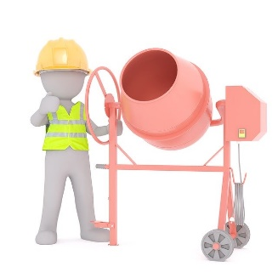

Question 8 (3 marks)
The Ghan train is an Australian icon. You can board the train in Adelaide and 2979 km later, after travelling via Alice Springs, you arrive in Darwin.
a) If you board The Ghan in Adelaide on Sunday 2:20PM and arrive in Darwin on Tuesday at 5:30PM, what is the average speed of the train journey?

Question 9 (2 marks)
Two cars travel toward each other on a 100 km straight stretch of road. They leave at opposite ends
of the road at the same time. The cars’ speeds are 100 km/h and 80 km/h. How long does it take for
the cars to pass each other?
